**Sequence Diagram:**

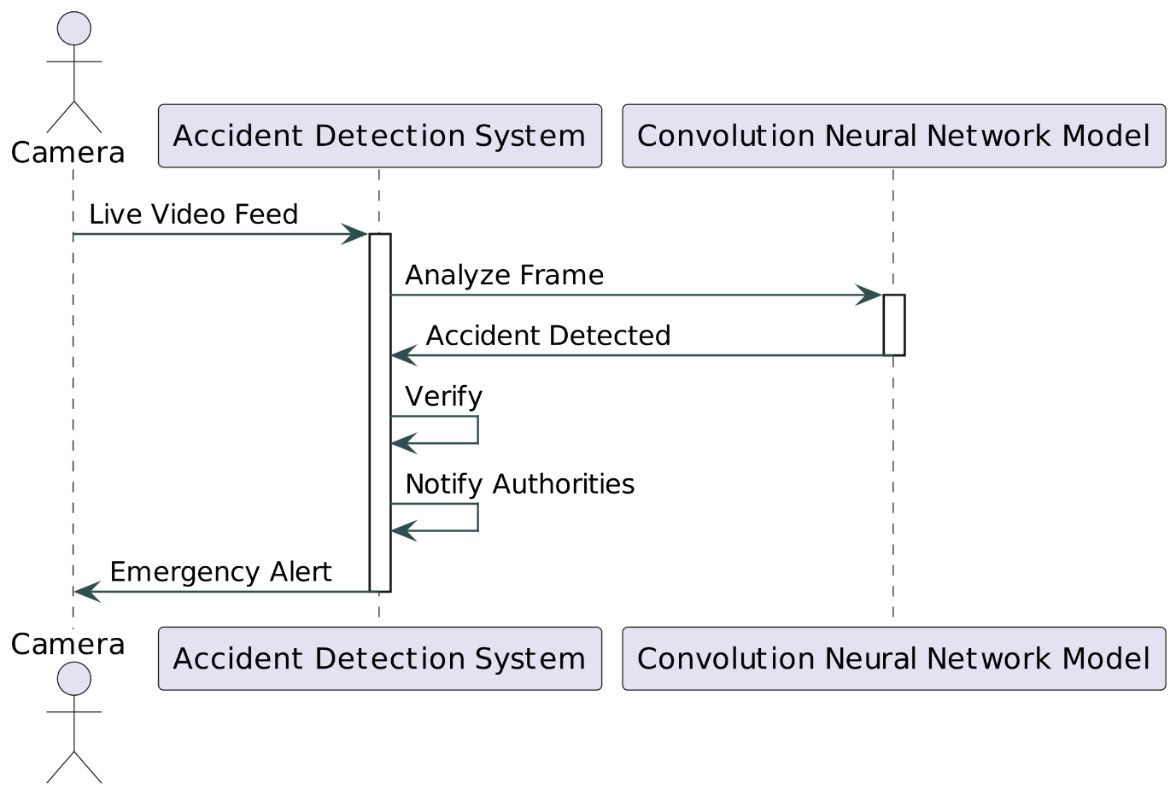

1. **Actors and Participants**:
   * **Camera**: Represents the highway CCTV camera that captures the live video feed of the highway.
   * **Accident Detection System (System)**: Represents the system responsible for detecting accidents based on the live video feed.
   * **Convolution Neural Network Model (CNN)**: Represents the deep learning model used by the system to analyze frames and predict accidents.
2. **Messages and Interactions**:
   * **Live Video Feed**: The Camera actor sends the live video feed to the Accident Detection System.
   * **Analyze Frame**: Upon receiving the live video feed, the Accident Detection System activates and forwards the frames to the Convolution Neural Network Model for analysis.
   * **Accident Detected**: The CNN model analyzes the frame and detects an accident. It sends a message to the Accident Detection System indicating that an accident has been detected.
   * **Verify**: The Accident Detection System verifies the accident detection to ensure its accuracy and reliability.
   * **Notify Authorities**: Once the accident is verified, the Accident Detection System notifies the relevant authorities about the accident.
   * **Emergency Alert**: Additionally, the system sends an emergency alert back to the Camera to trigger appropriate actions or alerts on the highway.
3. **Activation and Deactivation**:
   * The activation and deactivation of components (such as the Accident Detection System and the CNN Model) represent the periods during which these components are actively processing information or performing tasks.
4. **Time Flow**:
   * The sequence of messages in the diagram indicates the chronological order of interactions between the actors and components. Time flows from top to bottom, with messages being exchanged sequentially.

Overall, the Sequence Diagram provides a visual representation of how the various components of the accident detection system collaborate and communicate to detect accidents and notify the authorities effectively.